Reporter Knockin Mouse Models: https://getargeting-2026.vercel.app/reporter-knockin

- Can you put a dash between “knockout-first”:
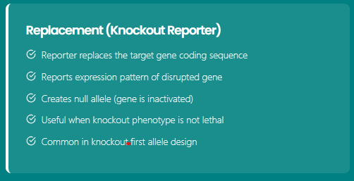

- Publications are not completely correct on this page. This is what they should be:
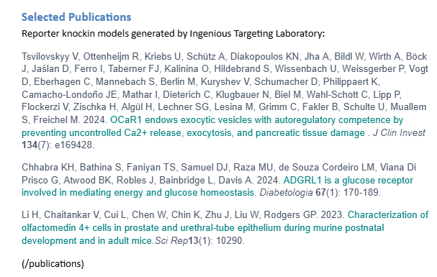

- Please remove “or IRES” and the s from the end of 2A peptides so that it reads “2A peptide sequences”:
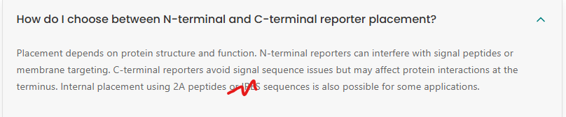
- Please remove the two yellow highlighted links and the pages they link to. For the green highlighted links, they go to 404 pages:
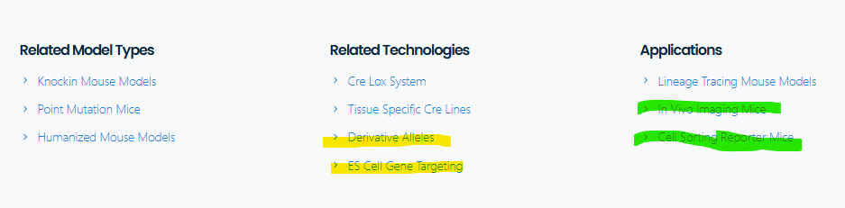

- Yellow links/pages need to be removed. Green link goes to 404:
